Project Plan

Paperless Testing System

Authors:
Abraham Ewnetu
Georgy Louis
Lewie Giammaria
Brady Word

Table of Contents
List of Figures 3
1. Introduction 4
1.1 Code Storage 4
1.2 Development Architecture 4
2. Scope and System Overview 4
2.1 Required Features 4
2.2 Out-of-Scope Functionalities 4
3. Overall Description 5
3.1 Product Perspective 5
3.1.1 User Interface 7
3.1.2 Memory Constraints 8
3.2 Product Functions 8
3.3 User Characteristics 8
4. Classes/Objects 8
5. Specific Requirements 9
5.1 External Interface Requirements 9
5.1.1 User Interface 9
5.1.2 Hardware Interface 10
7. Testing 10
8. Goals and Guidelines 10
9. General Constraints 10
10. Roles and Responsibilities: 10
11. Project Schedule 11
Appendix A: Use/Case Diagrams 13
Use Case : Professors Creating a Teacher Account 13
Use Case : Professors Creating a Course Session 14
Use Case : Professor Creating a Test For a Course Session 14
Use Case : Professor Publishing a Test 15
Use Case : Professor Viewing Grades. 15
Use Case : Students Creating an Account 16
Use Case : Student Registers for a Course 16
Use Case : Student Taking a Test 16
Use Case : Students Viewing Their Grades 16

List of Figures

- Figure 1. Context Diagram 6
- Figure 2. Flow Diagram 7
- Figure 3. UML Diagram 9

List of Tables

- Table 1. Roles and Responsibilities 10
- Table 2. Project Schedule 11

1. Introduction

The purpose of this document is to describe and define the design specifications for the automated grading system that is being created. This document will cover the basic outline of the design for the system’s components, inputs, outputs, functionality, architecture, and discuss how various components will interact with each other.

1.1 Code Storage

All code for this project will be stored on GitHub in the repository CMSC495PaperlessTestingSystem.
Members of the development team will need to have access to a GitHub account in order to access and contribute to the project code.

1.2 Development Architecture

- Using the the Java programming language because the development team has the highest level of understanding with this language.
- Making use of Spring framework to develop the application to increase efficiency.
- Database system (mySQL) that supports login to the application by storing authentication information and also supports functionality by being used to store grades earned on tests and display results to users.

2. Scope and System Overview

The Paperless Testing System is an application that allow professors to assess student’s knowledge on a particular subject. It allows professors to sign up as a teacher for courses, create a test, and design questions based on template format. After a student creates an account in the system, he or she will be able to enroll in courses and take tests that are available. The result of the test is automatically available as soon as the test is submitted. To generalize the access of the application, it will run on a web server and provide web pages interface.

2.1 Required Features

- Provide capability for teachers to create tests that are designed to be taken by students.
- Set up the test with the appropriate question type, including the weight of each question towards the overall points for the test, and the amount of time allowed to complete the test.
- Provide answers to questions so that the grading system will know how to score them as either correct or incorrect.
- Reset a test for a student or a group of students.
- Allow students to create an account and enroll in a course to take tests for that course.
- Display grades.
- Display a list of grades for all student tests taken for each individual class.
- Teachers will be able to publish the test to the class or classes that they have set up.

2.2 Out-of-Scope Functionalities

- Professor’s intervention in the grading process after test submission.
- Integration within teaching materials.
- Including questions with pictures.

3. Overall Description

3.1 Product Perspective

The paperless testing system is a website that use a database to store and organize data related to users and tests. This approach eases the access to this service via various types of medium such as computers, phones, and tablets.

Context Diagram
Context diagram is a boundary between the system, or part of the system, and its environment, showing the entities that interact with it. It is a high-level view of the system.

The purpose of a context diagram is to identify the responsibilities between entities to ensure that aspects towards the business are identified. It helps provide checks and balances as a request is made and the recipient responds to the request.

The following diagram will give a high-level system structure of how different entities work together to provide general information of what specific requirements are met. The diagram layout how data is transferred from one part of the system to another.
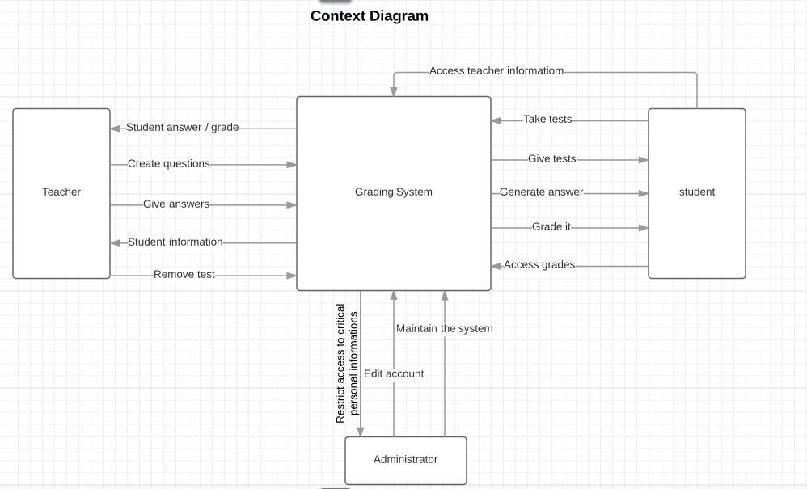

Figure 1. Context Diagram displaying the entities and interactions in the Paperless Testing System.

Flow Diagram

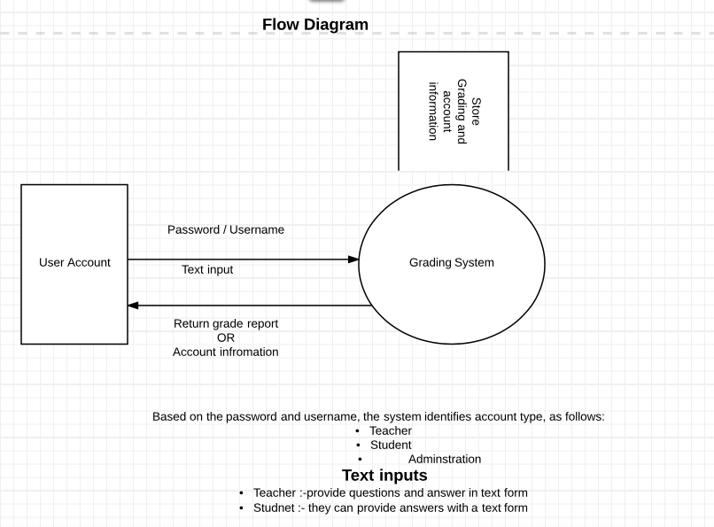
Figure 2. Flow Diagram showing the workings of the Paperless Testing System.

3.1.1 User Interface
The user interface will be made up of web pages since it offers the advantage of delivering services to everyone having access to internet and a web browser. A web browser is installed on every computer tablet or phone that one can buy in a store, including hardware capable of handling internet access. Therefore, the paperless testing system is guaranteed to offer convenient, uniform, and ready access. The UI will be constructed with the assistance of using the Spring Framework and the tools made available through its use.

3.1.2 Memory Constraints
The system is not intended to be a massive system, and will not require major amounts of available hard drive space or memory requirements.

3.2 Product Functions
Product functionality can be decomposed into the following areas:

- Professors creating an account.
- Professors creating tests for a course.
- Professors publishing tests.
- Professor viewing student grades.
- Student creating an account.
- Student registering for a course.
- Student taking a test.
- Student viewing their grade.

3.3 User Characteristics
The primary users of the paperless testing systems are students and professors. The professor's role consists of creating a test for their specified course and entering each particular question along with their respective answer. The students use the system to take a test related to courses in which they have enrolled and have the ability to view their grades.

For more details about the user characteristics refer to Appendix A on page 13. (Use Case/ Scenario).

4. Classes/Objects
Figure 3 displays the entity relationship diagram that shows how different objects collaborate together to provide various functionalities of the system. These services can be decomposed into different modules:
- Test Design module
- User Account module
- Testing Student module
- Grading module

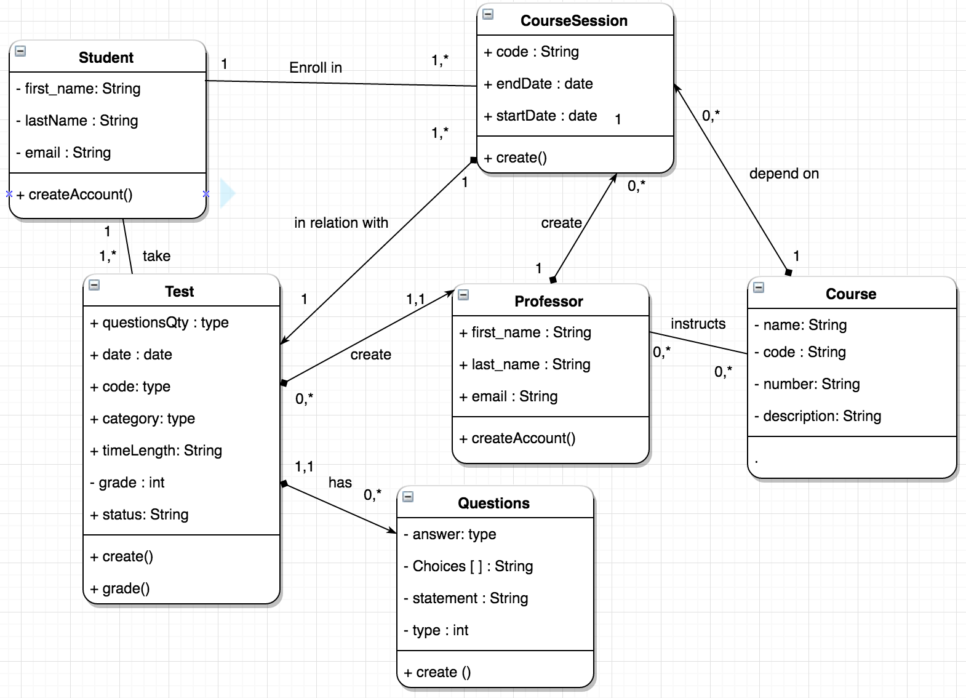

Figure 3. Entity Relationship Design Diagram (UML) which displays the classes and attributes associated with the Paperless Testing System.

5. Specific Requirements

5.1 External Interface Requirements

5.1.1 User Interface

Students
- The ability to access specific classes (optional) and specific tests that a professor has set up.
- An interface for during the test which includes ways to answer the questions appropriately and has a timer with the amount of time remaining if the test is timed.
- A way to view the grades they have received on previous tests.
Professors
- The ability to access the test creation generator.
- A way to view the grades that students received on their tests.
- A way to select their different class sections (optional).

5.1.2 Hardware Interface
The design of the automated grading system will not be complex and will be able to run on any standard Windows or Linux setup. Users will need to have a mouse, keyboard, and monitor to interact with and display the contents of the application.

6. Policies and Tactics
- Plans for testing will be defined in the Test Plan document.
- It will be coded using the Spring Framework, running on a web server.
- Adhere to Java style and security standards.
- The SRS document can be used to ensure requirement traceability by checking to see that all requirements specified in the document have been applied to the design of the application.
- End-users will need login credentials to access the application. Will also need a PC with browser and internet access.

7. Testing
- All testing details related to the Paperless Testing System will be described in the Test Plan document.

8. Goals and Guidelines
- There will be an emphasis placed on usability because the user interface will be used by students and professors with varying ranges of technical knowledge and training.
- The test generator needs to be easily modifiable and diverse so professors can create and tailor tests/quizzes to the subject of their class.
- The automated grading process needs to be modifiable also, to allow professors to vary the weight of each question and ensure the grading scale is appropriate for specific assignments.
- The system needs to be fully functional, tested, and deployable by the required due date.

9. General Constraints
- 8 week development period.
- Designed for users with varying backgrounds of technical knowledge, so user interface needs to be easy to understand and interact with.

10. Roles and Responsibilities:

Individual | Roles/Responsibilities
Abraham Ewnetu | - User interface (front end)  - SQL (data layer)  - Context Diagram  - Flow diagram
Brady Word | - Security Testing  - Project Plan creation  - SRS/SDS creation and updating  - User guide  - Test Plan and Project Design creation  - Login/Account creation functionality  - Will assist on frontend and backend development
Georgy Louis | - Database design  - Project Plan  - Project Design  - SQL Testing Script  - SQL Script  - Assist with back end development
Lewie Giammaria | - Assist in developing the SRS/SDS.  - Assist in developing the project plan.  - Develop the test plan.  - Assist in frontend development.  - Run the program quality testing.
Table 1. The names and roles/responsibilities of each member in the design team.

11. Project Schedule:

Week | Tasks | Assignments
Week 1  (March 13 - 19) | - Form Group | - N/A
Week 2  (March 20 - 26) | - Project Plan  - Begin SRS/SDD  - Determine Roles and Responsibilities  - Begin discussing Test Plan | - Turn in Project Plan
Week 3  (March 27 - April 2) | - Update SRS/SDD  - Discuss Spring Framework  - Create Test Plan  - Review Roles and Responsibilities to begin coding  - Begin work on coding the login/system account creation process  - Create database tables for storing account information  - Create test accounts for students and teachers  - Begin work on the User Guide  - Start work on question templates for test generator | - Turn in Test Plan
Week 4  (April 3 - 9) | - Verify the login and account creation processes are functioning properly  - Update SRS/SDD  - Begin work on the test generator/ continue work on question templates  - Start work on student and teacher UI  - Functionality and security testing for all operating components  - Continue work on the User Guide  - Start work on automated grading of tests  - Finish login and Account creation process | - Turn in Project Design
Week 5  (April 10 - 16) | - Update Test documentation/SRS/SDD/ User guide/ Development history  - Functionality and Security Testing on all created components  - Continue work on Student and Teacher UI  - Continue work on test generator  - Continue work on automatic grader for tests  - Finish question templates for test generator | - Turn in Phase 1 Source
Week 6  (April 17 - 23) | - Update Test documentation/SRS/SDD/ User guide/ Development history  - Functionality and Security Testing on all created components  - Finish work on Student and Teacher UI  - Finish work on test generator  - Finish work on automatic grader | - Turn in Phase 2 Source
Week 7  (April 24 - 30) | - Update Test documentation/SRS/SDD/ User guide/ Development history  - Functionality and Security Testing on all created components  - Specifically, using test credentials create a sample test to be taken by a test student account, and verify that the test is automatically graded appropriately upon completion and that both the test student and test teacher account can view the result of the test  - Fix any bugs or issues that arise from testing the entirety of the system | - Turn in Phase 3 Source
Week 8  (May 1 - 7) | - Finalize all Test documentation/SRS/SDD/ User guide/ Development history  - Ensure that all bugs and errors in functionality/security have been fixed  - Finalize deployment of application  - Develop conclusions for final project submission (design strengths, limitations, lessons learned, suggestions for future improvements | - Turn in Final Project

Table 2. Project Schedule containing the task that will take place and the assignments that will be due corresponding with the 8 week design/implementation schedule.

Appendix A: Use/Case Diagrams

Use Case : Professors Creating a Teacher Account

Professors create a teacher account that allow them to choose courses and submit test for students enrolled in these courses.

Precondition : The professor must have a valid email to be able to access the system.

Postcondition : The professor will be able to choose courses and access the main dashboard managing tests.

Actor Profile : The professor is willing to provide tests for students in courses that he or she will be responsible for.

Sequence of Events
- Access the teacher account creation module.
- Enter information related to the professor, including email, password, and access code.
- Submit the information.
- The test management main page is displayed.

Use Case : Professors Creating a Course Session

Precondition : A professor must have an account to log in to the system.

Postcondition : A professor is able to submit test for a course session, that students are able to enroll in.

Actor profile :

Sequence of Events
- Log into the system.
- Open the course creation session module.
- Select Course.
- Enter information regarding the course session being created.

Use Case : Professor Creating a Test For a Course Session

Precondition : A course session has been previously created.

Postcondition : Availability of a course session in which students are able to enroll.

Actor profile

Sequence of Events:
- Open the test creation module.
- Select a course session.
- Provide details about the test such as date availability range and time length.
- Choose a question template.
- Customize the question template.
- Enter data related to the question.
- Repeat choosing a question template and design the question until all questions have been created.

Use Case : Professor Publishing a Test
Professor publish test that become available to student after successfully being created in the system

Precondition : The test has has been created.

Postcondition : The test is available for students.
Actor profile :

Sequence of Events
- Open test publishing module.
- Choose a test previously created.
- Select test.
- Publish test.

Use Case : Professor Viewing Grades.
professor views grade for students

Precondition : Test has been completed by student.

Postcondition : Students Grades are displayed

Use Case : Students Creating an Account
Students create account that allows them to enroll in courses and take tests.

Precondition : Students can access the system and have a valid email.

Postcondition : Students are able to log in to the system

Sequence of Events
- Access the student creating account system.
- Enter and submit account related information.
- Access students main page.

Use Case : Student Registers for a Course
Students register for courses with the goal to access available tests.

Precondition : Student is logged into the system.

Postcondition : Student can take available tests.

Sequence of Events
- Students select a course.
- Enroll in this course.

Use Case : Student Taking a Test

Precondition : Student has enrolled in the course session related to this test.

Postcondition : Students successfully complete the test.

Sequence of Events
- Select a course.
- Select a test for this course.
- Answer each question in the test.
- Submit test.

Use Case : Students Viewing Their Grades
Student view grades for test that they have taken.

Precondition : Test is available for the course session in student has enrolled.

Postcondition : The grade is displayed if available.

Sequence of Events
- Access the grade module.
- Select a course test.
- Grade is displayed if available.

Scenario 1
- Student has selected a course.
- Student has not taken the test.
- No grade is shown.

Scenario 2
- Student has selected a course.
- Student has taken a test.
- Grade is shown.

